NSW Government Employment Enablement Strategy

High Growth Jobs, Talented Candidates Early learnings

20 December 2016

Funded by the NSW Government Department of Family and Community Services

Contents

Executive Summary 3
- Introduction 6
- Outcomes to date 14
- Learnings to date 18
- Next steps 22
Appendix A: Case study – Compass Group 23
Appendix B: Employment outcomes for jobseekers, and characteristics of the job seekers involved in pre-employment training 25

“Despite our expertise in working with people with a disability as clients, we still had to go through the steps to ensure that we could employ them as staff – we didn’t have the expertise and processes from the perspective of an employer of people with a disability. We still had to do the training and change the mindset of our organisation’s current employees.”

Health and Social Assistance Employer.

“I love the statement around the disability confident Australia. I think organisations probably have a tendency not to be confident in this space…. I just see this huge opportunity. I think it's the opportunity for us to explore some of those boundaries and to probably lead the way as an employer and a company to open up this market.”

Knowledge Employer.

Executive Summary

Overview

Statistics show that labour force participation rates for people with disability haven't improved in the last 20 years. To add to that, many employers wrongly perceive that employing a person with a disability will incur additional cost and risk to their business.
In order to improve these rates and misperception, the High Growth Jobs Talented Candidates (HGJTC) is an innovative program that matches people with disability with employers looking for candidates to fill roles in high growth industries.

Delivered by the Australian Network on Disability (AND) in partnership with Social Ventures Australia (SVA), and funded by the NSW Department of Family and Community Services, the program works with eight businesses employing around 57,000 staff nationally.

In addition, five Disability Employment Service (DES) provider or disability specialist organisations (employment service providers) have been selected to support the program by sourcing suitable candidates.

HGJTC uses a demand-led brokerage model that starts with the employer to build their confidence to employ people with a disability, and works backwards to prepare and match job seekers to identified jobs.

There are four main components:
- Engage and understand employer needs
- Equip employers
- Engage and equip service providers
- Deliver and review

Outcomes to date

Six of the eight employers have moved through the ‘Engage’ and ‘Equip’ stages into the ‘Deliver’ phase. They have increased their awareness of the diversity, skill level and talent of people with disability, and improved their systems and processes to improve the recruitment and retention of people with disability.

The five employment service providers have learnt about the demand-led brokerage model and participated in the co-design and delivery of pre-employment training. Three have also participated in AND’s Disability Confidence Training with employers, and an employment service provider workshop is scheduled for early February 2017.

44 roles have been identified across the employers that have moved into the ‘Deliver’ phase of the program. 56 job seekers have participated in pre-employment training across the employers with a 90% completion rate. 15 people with disability have commenced and remain in jobs.

Learnings to date

Our experience to date confirms that system change within employers is a necessary first step to increasing participation of people with disability in the workplace.

For example:

- Among employers, there is little understanding of the breadth and diversity of disability in Australia.
- Employers generally don’t have policies and procedures in place to support the recruitment and retention of people with disability (e.g. workplace adjustment).
- Position Descriptions (PDs) generally do not clearly identify inherent requirements (or mandatory qualifications or clearances).
- Standard recruitment practices are a barrier to people with disability.
Research indicates employers are more likely to hire people with disability and update their processes to be accessible and inclusive, if they are supported to do so by an external organisation with recognised expertise.

Once a relationship has been built with the employer, and there is a deeper understanding of access and inclusion, employers have been willing to:

- Allow employment service providers onsite to interview supervisors and conduct a job analysis to deeply understand the role and environment.
- Be involved in the co-design and delivery of short pre-employment training.
- Release HR teams and line managers for disability confidence training.
- Make sometimes small, but important changes to their recruitment practices.
The process to review recruitment policies and develop workplace adjustment policies and practices typically takes many months, and requires considerable work across multiple business units to develop policy and procedures that will be effective in the long term. This is preferably co-ordinated by a dedicated resource within the employer that can act as a single point of contact.

Employment service providers have indicated that it is worth taking the time to equip themselves with relevant information and training from AND, visit potential employers on the job site and thoroughly review the job analysis documentation. These three steps have helped to ensure that they put forward the most suitable candidates and adequately prepare those candidates to meet the job requirements.

Once connected to an equipped and engaged business, employment service providers have:
- Proven to be extremely responsive to employer needs.
- Constructively participated in the co-design and delivery of pre-employment training.
- Provided a high standard of selection, matching, onboarding and post-placement support.
The employment service providers indicated that this level of connection has not been possible to achieve outside of the HGJTC initiative.

To summarise, our experience shows that engaging employers, and encouraging systemic changes to their systems, processes and culture are made, requires a significant commitment of time and a specific skill set from the external organisation supporting them (in this project, AND). This is particularly so for employers in high growth industries that are undergoing rapid change across their whole business.

Employment service providers, such as DES, are not currently funded to provide this service, nor do they have the expertise.

For job seekers with disability, where the demand-led brokerage model has been followed, interview and selection processes have been more successful than where there have been gaps in the process. For example, there has been less success where there have been gaps in disability confidence training with employers (due to unavailability of staff or changes in personnel) and explicit conversations around the need to look beyond employment gaps have not occurred.

Importantly, the experience for candidates participating in the HGJTC project has been overwhelmingly positive, and includes increased confidence and motivation for all candidates whether they have been successful in securing a job or not.

These learnings give credence to the unique need for, and value of, a demand-led brokerage model to improve the participation rate of people with disability in the labour force.

Introduction

Context

Across Australia, employers’ lack of awareness and confidence in systems that help recruit and retain people with disability and the absence of an effective system to match the needs of jobseekers with disability with vacancies, results in low employment participation by people with disability. The labour force participation rate of people with disability has remained at around 53 percent for more than 20 years.

As the recently released Department of Social Services (DSS) Discussion paper cites “the Melbourne Institute of Applied Economic and Social Research…found that people with disability face barriers to employment that measures which solely focus on the job seeker are unlikely to overcome. In particular, they found a need to address the incentives of employers and potential employers of people with disability to improve overall outcomes for people with disability.”

For employers getting the right person for the job – the job match – is critical. Some employers perceive employing a person with disability is associated with additional cost and risk. With the ageing of Australia’s population, and industry demands for a more highly skilled labour force, it is possible that people with disability will fall even further behind the rest of the population in terms of workforce participation. Employer perceptions of cost and risk therefore need to be addressed.

“…the worst obstacle that people with disability face in getting employment is employer ignorance; not employer unwillingness, but employers seen simply not to know what, how to hire a person with disability, how to work out whether they're a good match for the job. Once they're hired, how to support them in the role, how to prepare the workplace, how to make sure the employees who will be working with a person with disability understand the situation.”

Susan Ryan, former Age and Disability Discrimination Commissioner, speaking on the preliminary findings of the Willing to Work Inquiry ABC Radio 25/8/15.

The Australian Government Disability Employment Services (DES) system is not performing strongly enough for job seekers or employers. Around 31 per cent of participants are in employment three months after completing a period of assistance in DES. This figure is down from a high of 38 per cent in 2013 and the current equivalent figures for jobactive of around 40 per cent. Employers consistently report concerns that the focus is on the jobseeker at the expense of employer; not enough time spent understanding employer business and needs/job roles/core competencies; there is a failure to refer candidates who can meet their vacancies (poor job match); there are too many employment service providers approaching employers and employers don’t know which ones offer quality service; ongoing support for employment is unreliable and ineffective, and the system is difficult to navigate.

Our response

The New South Wales (NSW) Government launched the Employment Enablement Strategy (EES) to increase participation of people with disability in employment and further education. The ESS has two objectives: provide employment-preparedness support to adults with intellectual disabilities; and build the capacity of businesses to employ people with a disability.

The High Growth Jobs, Talented Candidates (HGJTC) project links business to people with disability with employers seeking candidates to fill roles in high growth areas. It is designed to increase employers’ capability to employ people with disability, while at the same time helping to better prepare candidates with disability for the jobs of the future. The project focuses on the needs of employers and candidates, ensuring an effective job match.
The diagram below presents the key components of the project.

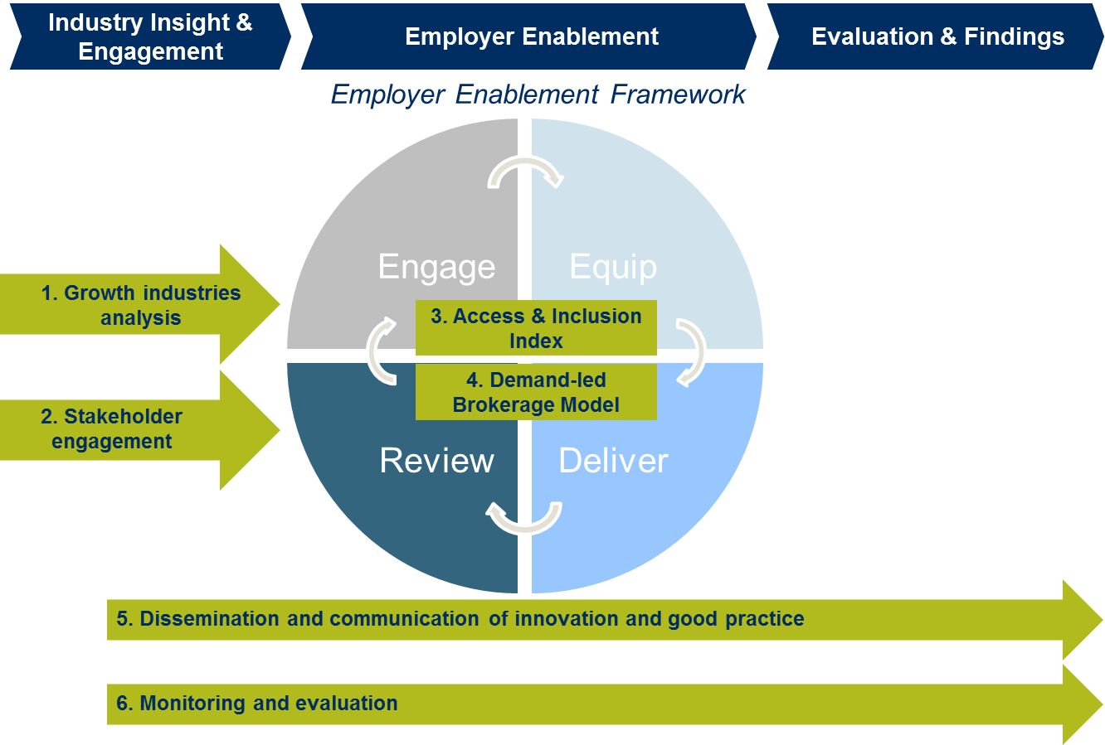

Figure 1.1 High Growth Jobs, Talented Candidates project components

Delivered by the Australian Network on Disability (AND), in partnership with Social Ventures Australia (SVA) and funded by the NSW Department of Family and Community Services, HGJTC is working with eight businesses employing around 57,000 staff nationally.

Participating employers to date are Australian Unity, Life Without Barriers, Uniting (Health and Social Assistance), IAG, Fujitsu, Infosys (Knowledge) and Accor Hotels and Compass Group (Food and Accommodation Services).

HGJTC uses a demand-led brokerage model that starts with the employer and works backwards to prepare and match job seekers to the job. The process starts with the employers building their disability confidence through expert training provided by AND. Specific roles and sites are then identified and a Disability Employment Service (DES) provider or disability specialist organisation (employment service providers) is engaged. Working together, AND and the employment service provider invests time to gain a deep understanding of the job requirements and organisation’s culture. A pre-employment training program (co-designed with the employer, employment service provider and AND) provides candidates with knowledge of the employer and role prior to the interview and selection process, helping to ensure that the right person, with the right skills and attitude is found for each position.

Along with other development partners, this project has also significantly contributed to the development of the Access and Inclusion Index. The Index is an online resource for employers to build their capabilities to make their businesses accessible and inclusive to customers and employees with disability.

Purpose of this paper

In the context of ongoing changes to significant initiatives that impact the employment of people with disability, the purpose of this paper is to share what has been learnt to date since we commenced engagement with employers (September 2015 – December 2016).

Some of the most significant of these initiatives include:
- Through Jobs for NSW, the NSW Government is focused on increasing the employment of people with disability – the Government also has potential to achieve this objective through the Smart, Skilled and Hired disability workforce capacity building stream of activity.
- Public consultations are currently open on reform options for the Australian Government-funded Disability Employment Services program to improve its performance in placing people with disability into employment.
- The National Disability Insurance Scheme continues to be rolled out across Australia with the expectation of direct employment growth for between 7,800-12,400 people with disability on a full-time-equivalent basis in NSW. This roll out in NSW is being complemented by a $18.9m NSW Government investment in rapidly scaling up the disability sector workforce.
This paper draws on:
- Debrief conversations between employment service providers and AND following pre-employment training and recruitment phases.
- Ad hoc feedback from employers and discussions at employer roundtables.
- Project activity data collected by AND and analysed by SVA, including employer evaluations of disability confidence training.
- Job seeker questionnaires.
- Data extracts from employment service provider systems.
- Access and Inclusion Index website usage.
A full evaluation of the program is planned to be conducted by SVA from June – September 2017. The evaluation will include an overview of the outcomes generated by the project for employers, job seekers (including employment and wellbeing) and employment service providers; a comparison of the outcomes from the program and other initiatives with similar objectives (e.g. Disability Employment Services); an assessment of the investment required to generate these outcomes (including unit costs); and recommendations to inform future program and policy development.

Activity to date

Engage

The High Growth Jobs, Talented Candidates project focusses on employers in high growth industries based on the premise that these employers have the best chance of providing sustainable employment opportunities and that the return on investing in their disability confidence is high. Through the growth industries analysis conducted by SVA, three industries were identified to have high employment growth potential in NSW. These industries are Healthcare and Social Assistance; Knowledge; and Food and Accommodation Services.

Since September 2015, AND has had discussions with 12 employers from across these three industries to determine their ability to meet the entry criteria of the project – namely job growth and capacity to participate, given other priorities, within the project timeframe. The eight employers participating in HGJTC were able to meet this criteria, and have committed to recruit, retain and develop employees with disability.

Employers confirmed that the drivers for them to engage were consistent with those identified by AND, including:

- Attract talent: recruit from entire talent pool and meet the demands of increased employment growth.
- Retain: knowledgeable employees who have and acquire disability.
- Reflect: the community in which they operate and current and potential customers/clients.
- Build reputation and brand: influence as an inclusive employer, service provider of choice; promote rights and wellbeing of people with disability.
- Customer and client alignment: NSW and other Government tenders increasingly ask for disability employment plans and other customers in their supply chain are committed to increasing disability employment, including AND members Westpac Group and the Department of Defence.
- Mitigate risk: understand and better meet legal obligations under the Disability Discrimination Act such as workplace adjustment.

Equip

AND has developed the Access and Inclusion Index as part of this project. It has conducted the Quick Self-Assessment with seven employers to date. Most scored 2 or 3 out of 10 which confirmed conversations with employers during Engage that they were at the start of their journey to disability confidence and would benefit significantly from the Equip services. These have included:
- Recruitment reviews with six employers, all of which are in the process of changing their policies and procedures in response to recommendations provided.
- Developing workplace adjustment policy and procedures for four employers and reviewing a fifth, resulting in all five making improvements in this area.
- Delivering Disability Confidence Training for over 140 HR teams and site managers across five employers.
- Reviewing Premises for two employers which identified the next upgrade improvements.
Prior to moving into the Deliver phase AND, with SVA’s support, ran an expression of interest (EOI) process to select employment service providers to partner with AND. It was made clear that no additional funding would be involved and that they would need to be willing to commit their DES fees to cover the cost of short pre-employment training. Five organisations are partnering in this phase: three generalists - MAX Employment, ORS Group and OCTEC and two specialists - Vision Australia and Aspect Employment (the only non DES provider engaged).

Deliver

Phase three of High Growth Jobs Talented Candidates involves delivering a brokerage service to connect employers to talent via employment service providers. Key elements of the deliver phase have included:
- Identifying skilled, semi-skilled and customised roles which HGJTC employers are recruiting for within NSW. To date these have included a range of roles including food and beverage attendant and kitchen hand, housekeeper, warehouse stock administrator, IT repair centre technician, disability and aged care support worker, call centre operator and Local Area Co-ordinator for the NDIS. Roles have been identified across Sydney, the Central Coast and Illawarra/Shoalhaven.
- Undertaking a deep job analysis of each role including a site visit, and detailed discussions with site managers to understand the inherent or essential requirements, mandatory qualifications or clearances, the most important attributes identified by line managers and their ideal candidates. AND has undertaken a job analysis for 22 job roles across six of the eight employers (in some instances, DES employment service providers also participated in this process).
- Informing employment service providers about demand-led brokerage and the importance of employer centred pre-employment training instead of generic interview coaching.
- Co-designing and delivering short pre-employment training tailored to the particular employer and role. This includes an onsite employer briefing to potential candidates and walk through the premises if possible, followed by training at employment service providers to build practical skills and reinforce key messages from the employer information session. For some roles, additional days have been spent delivering formal qualifications such as Responsible Service of Alcohol and White Card or Fork Lift certificates.
- Modifying the employers’ recruitment process to ensure that people with disability have an opportunity to participate but that the process remains as close as possible to business as usual and can be sustained. In most cases, the change has been to allow the candidate to have a support person (from the employment service provider) with them in the interview. In some cases, employers have made the interview process less formal. A key conversation with employers at this point has also has been around the need to accept that people with disability will most likely have significant employment gaps in their resumes. Many recruitment processes would automatically screen out such candidates.
Understanding the role

“The job analysis helps. It helps, not only to make sure that people can do the job and look at the requirements, but it helps in the interview preparation because you can structure questions around a certain function and make sure that people are prepared.”

Employment service provider.

Value of on-site employer information sessions

“To be honest, when we first spoke to [the potential candidate] about it, he was hesitant and we asked them to come to the information session and we’ll have a chat and see if we are interested. After the information session about [employer], he said he was definitely keen. It is hearing it from employees doing [the job]. You can ask questions, and you can think about, ‘is this me or not me?’ He came back and said that he is definitely interested.”

Employment service provider commenting on DES client subsequently employed as a Disability Support Worker.

“If you get the employer talking about what their expectations are, people are much more engaged to be able to make an informed decision.”

HGJTC candidate who successfully secured a role.

Inclusive recruitment processes

“On the day of the interviews [the employer] was really good with the assisted interview. In the interview process, [the interviewer] would talk with the participant and then asked me for any supporting information or key information the participant had not covered.”

Employment service provider.

Inclusive recruitment processes

“Our normal recruitment processes would have screened out most of the candidates – mainly due to work history gaps. But this process has meant we’ve got some great talent for our business, people we would have ruled out.”

Food and Accommodation Services Employer.

Outcomes to date

Success to date

The demand-led model and associated investment to deeply understand an employers’ business and the job role is paying off:
- Candidates are highly motivated by the promise of a tangible job opportunity.
- Deep engagement to understand the employer and the role increases the ability of employment service providers to identify candidates who understand, and can perform the role and have a high probability of being a good match.
- Short pre-employment training which is co-designed and delivered by employers helps build confidence and skills directly relevant for the role, interview and selection process.
- Employers are adjusting their hiring practices to meet the needs of people with disability.
- People with disability are proving to be a great match for employers.

Outcomes for employers

To date, employers participating in the demand led brokerage model have:
- Increased their awareness of the diversity, skill level and talent of people with disability through Disability Confidence training and numerous meetings with AND.
- Improved their systems and processes to improve the recruitment and retention of people with disability through changes to their recruitment and workplace adjustment practices.
- Employed people with disability (in some cases at a higher application to offer ratio than the employer’s general application process: 29% vs 19%).
The case study in Appendix A illustrates some of the processes and outcomes in the project for employers to date.

Motivation to change

“I picked up on a lot of things I was previously unaware of in the industry and closed some gaps on some areas I was not confident, such as ‘person first wording’. The most memorable part of the training for me was where [the AND trainer] spoke about disabilities as rather ‘not being disabling at all until there is a social barrier in the way’ – such as stairs for a wheelchair user etc. I knew (on a more superficial level) we needed to make changes– but that really drove it home for me!”

HR Officer, HGJTC Employer following Disability Confidence training.

Four of the HGJTC employers have introduced changes that go beyond the project but that are attributed to it. These changes include:
- Introducing disability employment targets into their recent Accessibility and Inclusion Action Plan.
- Participating in other disability employment initiatives such as Ticket to Work.
- Starting to make changes to ensure their business is accessible to customers with disability.
Benefits beyond recruitment

“One of the benefits that comes from a more flexible workplace is our internal turnover or attrition actually slows down. We also see higher engagement from our employees, which translates to better customer experience…the motivation for doing this is we see huge employee benefits and customer benefits. And we also see community benefits.”

Knowledge Employer.

Beyond the eight employers that are being supported through this program, a number of employers have used the Access and Inclusion Index to better understand the extent to which their organisations are accessible and inclusive to job seekers, employees, customers and suppliers with a disability. Since July 2016, 123 organisations have completed the quick self-assessment, 75 AND members have registered for the comprehensive self-assessment, and 24 have started to undertake this “deep dive” into their accessibility and inclusiveness.

Outcomes for job seekers with disability

To date:
- 44 roles have been identified across the six employers that have moved into the Deliver phase of the program.
- 56 job seekers have participated in pre-employment training across the employers with a 90% completion rate.
- 15 people with disability have commenced and remain in jobs.
Details of the employment outcomes, and the characteristics of the pre-employment training participants (including comparisons with DES participants), are included in Appendix B.

Value of pre-employment training co-designed and delivered with employers

“It was good for them [our jobseekers] to hear all about the jobs and the functions. It had more credibility coming from the employer than it does coming from an [employment] agency. When people are unemployed, I think they hear a lot of things from people who do not know the job.”

Employment service provider.

The experience for job seekers has been overwhelmingly positive. In the case of one employer there was some minor stress and pressure caused due to miscommunication about the length of time between the pre-employment training and the job offers, and the addition of requirements throughout the recruitment process (e.g. police checks, work rights documentation, responsible service of alcohol certificates).

Employment

“I can’t thank you enough, everyone that has helped me get this job. I’m so happy, I’ve even been asked to work an extra shift tomorrow. This time last year, I cried every day, now I am just so happy! Everyone is so proud of me which feels great.”

HGJTC Boardroom attendant.

Employment benefits wellbeing

“There has been happy tears along the way, that now they can get on with their life. And be working people. And I guess the prestige of working in the city at [employer] has been something that has been really well received by the candidates.”

Employment service provider

There is anecdotal evidence that participation has brought increased confidence and motivation for all candidates and that this has increased job outcomes including those who have not been hired by HJGTC employers.

Value for candidates of project with a connection to a real job

“For potential employees, it is a really different experience for them to hear that employers want to employ them. They aren’t made to feel like a burden. This is a real motivator, even for candidates that weren’t ultimately successful. Whether successful or not, it’s a positive experience for the candidates, and gives them increased confidence for future opportunities.”

Employment service provider

Outcomes for employment service providers

Three of the employment service providers have participated in AND’s Disability Confidence Training with employers, and an employment service provider workshop is scheduled for early February 2017. This workshop will include a specific learning session on employer engagement as well as how they can apply the learnings from HGJTC across their business.

HGJTC aims to influence the employment service providers involved in the project to reflect on their current practices, and adapt their service delivery to better meet the needs of employers. It is too early in the project to assess if these outcomes have been experienced by the providers and this will be captured towards the end of the project through interviews.

Value of employer commitment

“It has been an incredible opportunity to have a real employer with real jobs.”

Employment service provider.

Employment pathway creation

“I've got sitting on my desk right now, thank you letters from candidates saying ‘Thank you for believing in me.’ And the most gratifying part about it is seeing the smile on their face and even if they did not get the job, they are happy for us to market them to other employers and they are able to apply to other organisations, they are engaged, motivated… This is certainly where there is a role for everyone in the [Disability Employment Services] industry and it is about introducing them to employers.”

Employment service provider.

The value of the demand led approach

“[The jobseekers with disability] could see that there was an employer behind this, not just a pie in the sky. They could see that there were jobs available on completion, if they address the criteria.”

Employment service provider.

Learnings to date

Engaging employers

- All employers who met the project criteria have agreed to participate. This underscores the importance of investing in research to select employers with strong alignment and that have sufficient recruitment volume to justify the investment required.
- Deep employer engagement in complex organisations takes time. More specifically, to get buy in from across the organisation and operations, commitment from senior leadership within employers, and engagement with HR, recruitment teams and site managers who will hire and supervise the new employees with disability, is essential. Without this, engagement is likely to be lengthy and action delayed or not forthcoming.
- Employers benefit from appointing a dedicated resource (e.g. Disability Project Lead) at middle management level as a single point of contact within the organisation to co-ordinate efforts to be accessible and inclusive. The dedicated resource is most effective when they have a good understanding of the business and how decisions are made, and have some internal authority (usually conferred from an executive sponsor).
- Employers who are growing are also undergoing rapid change to meet this growth. New recruitment structures and processes are being developed and new staff hired, especially for health and social service employers delivering the NDIS. This has slowed down engagement with key staff. It has made it more difficult to develop an understanding of current hiring practice and to develop adjustments which will work now and can be sustained after the project finishes.
- The demand-led approach means responding to employers and going at their pace. It is hard to predict how quickly employers will progress through each phase of the project (Engage, Equip, Deliver, Review) as there are a multitude of variables affecting this. Some employers who started Equip later than others have moved more quickly to the Deliver stage. However, Deliver is occurring later than hoped for and we now expect a small number of candidates into jobs by the end of 2016. We expect further numbers to flow in 2017 but this will mean the cohort we are tracking for sustainable job outcomes (26 weeks and beyond) will be relatively small. This suggests there would be benefits in extending the HGJTC project beyond 30 June 2017.
Level of change experienced by rapidly growing employers

“We’re really undergoing a business integration and transformation at the same time.”

Health and Social Assistance employer.

Equipping employers

- Amongst employers, there is little understanding of the breadth and diversity of disability in Australia and lack of knowledge about disability discrimination and privacy legislation. In one case, line managers expressed strong views that people with a mental health illness should be forced to disclose their disability at an interview.
- Employers generally don’t have policies and procedures in place to support the recruitment and retention of people with disability (e.g. accessible recruitment procedures and workplace adjustment policies and procedures). Only one of the eight employers had a workplace adjustment policy in place.
- There is often a poor understanding of the concept of workplace adjustment, with confusion around work, health and safety processes, and minimal or no knowledge of the existence of government funding to support workplace adjustment. Some HR teams expressed concern that providing a workplace adjustment in the recruitment phase would be offering candidates with disability an ‘unfair advantage’.
- Position Descriptions (PDs) generally do not clearly identify inherent requirements (or mandatory qualifications or clearances), which may be contributing to the low suitability of candidates referred to employers by DES employment service providers outside of the HGJTC project. In some cases, considerable work was required to identify inherent job requirements with employers, and then obtain agreement from key personnel so that these were integrated into revised PDs.
- Online and other standard recruitment practices are a substantial barrier for people with disability – either because there is no provision to ask for a workplace adjustment or because software or practices automatically screen out candidates who have employment gaps in their resumes. Some employers are using recruitment agencies to source candidates which adds further complexity and possible unintended bias against candidates with disability.
- The process to review recruitment policies and develop workplace adjustment policies and practices typically takes many months, and requires considerable work across multiple business units to develop policy and procedures that will be effective. Where system changes have been required required (for example, to ensure a candidate can request a workplace adjustment within an online application and that it is acted upon), this has proven to be a complex and time-consuming procedure for all employers. However, the time investment has been essential to ensure that systemic changes are made to employment processes.
The need for workplace adjustment policies and procedures

“The big gap we see is a break down in terms of who owns the process….we are finding people at the recruitment stage or later through employment may disclose a disability or workplace adjustment that is required and then something may or may not happen…the real struggle we are finding is when the workplace adjustment is not an easy one that we see all the time…we are finding that when that is needed there is no process, no progress being made… We need buy-in from [stakeholders including IT and procurement] to make sure this happens.”

Knowledge Employer

- There is anecdotal evidence that the large number of interactions within employers through the engage and early equip phases spreads knowledge and helps change attitudes about disability within the organisation, even before formal disability confidence training with HR teams and site managers commences.

Delivery of brokerage to match people with disability with employers

- Employer research indicates employers are more likely to commit to hiring people with disability and make systemic changes to their processes to be accessible and inclusive, if they are supported to do so by an external organisation with recognised expertise.
- However, to achieve this systemic change, the external organisation is required to invest a significant commitment of time and have a specific skill set. DES providers are not currently funded to provide this service, nor do they have the expertise.

Value of external provider with recognised expertise and time

“Without the supports from external organisations, this wouldn’t be effective in our company. It takes effort for a company to pull together a program themselves – while we might have employed people with a disability in the past, there needs to be a program to ensure scale and sustainability, and it’s hard for businesses to find resources to develop and deliver this themselves.”

Knowledge Employer.

“A real rigour is required to work with complex organisations like ours.”

Knowledge Employer

“An important part of it for us is seeing that each step is being done with longevity and sustainability in mind. The time investment up front is worth it for that.”

Knowledge Employer

- Once a relationship has been built with the employer, and there is a deeper understanding of access and inclusion, employers have been willing to:
  - Allow employment service providers onsite to interview supervisors and conduct a job analysis to deeply understand the role and environment.
  - Be involved in the co-design and delivery of short pre-employment training.
  - Release HR teams and line managers for disability confidence training.
  - Make sometimes small, but important changes to their recruitment practices.
- Employment service providers’ feedback confirms that it is a worthwhile investment of time to meet with AND, participate in a site visit, and review the job analysis documentation to ensure that they can put forward the most suitable candidates and prepare those candidates to meet the job requirements. Employment service providers indicated that this level of connection has not been possible to achieve outside of the HGJTC initiative.
- Once connected to an equipped and engaged employer, employment service providers have proven to be extremely responsive to their needs, constructively participated in the co-design and delivery of pre-employment training, and provided a high standard of selection, matching, onboarding and post-placement support.
- However, where the demand-led brokerage model has not been followed, for example where have been gaps in disability confidence training with employers (due to unavailability of staff or changes in personnel) and explicit conversations around the need to look beyond employment gaps have not been had, interview and selection processes have been less successful.
- Minimum benchmark hours have sometimes not been met, due to the shift away from permanent to contract or casual, low minimum hours requirements by employers, particularly for care work and food and accommodation services. This trend in care work is likely to increase as the NDIS and aged care reforms are implemented and providers maximise flexibility of their workforce due to uncertainties in forecasting service demands.

Next steps

The High Growth Jobs, Talented Candidates project is due to conclude in mid-2017. The remainder of the project will be focussed on:

- Commence equip and deliver with the two employers who have delayed their involvement.
- Finalising equip with six employers and continuing the deliver phase with them.
- Placing more job-seekers into jobs and supporting them to retain those jobs.
- Assisting employers to make sustained changes to their systems, processes and workplaces so that they are more accessible and inclusive for all their existing employees, future candidates and recruits.
- Supporting employers to undertake the comprehensive Access and Inclusion Index towards the end of the project, in order to identify gaps and priorities for future work.
- Encouraging employers to act as advocates for candidates with disability – backed by their own positive experiences and outcomes.
- Extending relationships between employers and employment service providers as ongoing recruitment partners – this is already occurring in some cases.
- Using the learnings from HGJTC to inform the new Disability Employment Services from 2018.
- Documenting and evaluating the model - the final evaluation is due to be completed by SVA in September 2017.

Appendix A: Case study – Compass Group

Compass Group: Matching high growth jobs with talented candidates to meet employer commitments

Rosie McArdle, Compass Group Australia Executive Director HR and Risk, said at the commencement of the project in March 2016 that they hoped to build on the strong commitment they've made to ensure 10 per cent of their Australian workforce are Indigenous. She said: ‘We've made some progress on employing people with disability outside NSW and this project gives us the opportunity to bring that to NSW.’ Part way through the project Compass Group created a full-time Diversity Coordinator role to be the central point for the HJGTC project and other disability employment initiatives they are undertaking. This has contributed significantly to the outcomes achieved to date, given the complexity of Compass Group and the fact that HGJTC employees will all be employed at Compass Group client sites. To date Compass Group has employed six people with disability (and a further five have job offers) as part of their commitment to employ 20 people with disability by July 2017. During this process, Compass Group has agreed to offer permanent part-time roles at the Westpac sites and a minimum number of hours for casual contracts at the Taronga Zoo site.

AND and Compass Group agreed to focus the first round of recruitment at Westpac’s Sydney corporate offices where Compass Group has the contract to provide food and beverage services for functions and corporate staff. Like Compass Group, Westpac Group is a founding and Platinum member of AND. AND has worked closely with Compass Group to help build their disability confidence including training for their site managers across the two Westpac sites. To date four candidates with disability have been employed in permanent part-time roles as boardroom attendants, kitchen hands and café staff with most working at least 20 hours a week. Candidates were sourced and supported by MAX Employment who worked closely with AND and Compass Group to co-design a four day pre-employment training course that included an on-site employer information session and walk through, hands on training and mock interviews that ensured candidates were ‘Compass Ready’ ahead of being put forward for interview. Compass also agreed to modify their recruitment process to allow all candidates to be interviewed informally and to have a MAX Employment consultant with them in response to their requests for workplace adjustment. MAX Employment are continuing to provide post placement support for the new employees and site managers at Compass Group. Since they’ve started work, candidate and employer feedback has been very positive. Rosie McArdle has said ‘it has been an intrinsic motivator for line leaders which you can’t pay or train for.’

Teremoana, 43, from Belmore, started work in October 2016 with Compass Group. Teremoana works as a Board Room attendant at Westpac’s Kent street headquarters – a catering contract held by Compass Group. Her job involves organising rooms for meetings and functions, drinks, morning tea, lunches, afternoon teas and attending to any needs of meeting attendees. She has a permanent part-time role with Compass and works additional hours, hopefully moving to a full time role in the near future.

‘I was out of work for two years. Although I returned to housekeeping, my knees couldn’t handle the demands of the job. Compass is giving me great support. Previously I tried to hide my disability but I just can’t do that anymore. This role is great. I work in four hour shifts and I can manage my condition much better,’ said Teremoana.

‘The shift work works really well for me. When I’m at work I don’t have to hide my disability, I can be myself. I never thought I’d find a full time role like this. I have done so many other courses and got nowhere but this one has worked and I’m so pleased I did this program. It is awesome,’ she said. ‘This program is a great thing for [people with] disability. I am really proud to have this job. I feel special and I feel important to be a Board Room attendant for a big bank. It is awesome stuff,’ she said. Mother to five grown up children, Teremoana hopes that her commitment to finding employment makes her a better role model. ‘I want them to be proud of me. I didn’t have to give up because of my bad knee,’ she said.

Appendix B: Employment outcomes for jobseekers, and characteristics of the job seekers involved in pre-employment training

To date, 6 employers have moved to the deliver phase of the project. The outcomes for jobseekers are shown in the table below.

Employer |  | Preparation |  |  |  |  |  | Commencement
 | # jobs identified to date | # job  seekers participating in information sessions | # job seekers started pre-employment training | # job seekers completed pre-employment training | # job seekers apply for jobs | # job seekers offered interviews | # job seekers provided job offers | # job seekers started in job | # job seekers with workplace adjustment
Uniting | 10 | 5 | - | - | - | - | - | - | -
Life Without Barriers | 7 | 24 | 15 | 14 | 12 | 4 | 3 | 3 | 1
Compass | 12 | 48 | 26 | 24 | 20 | 20 | 9 | 9 | 4
Fujitsu | 4 | 20 | 15 | 12 | 12 | 7 | 4 | 3 | 3
Australian Unity | 7 | - | - | - | - | - | - | - | -
IAG | 2 | - | - | - | - | - | - | - | -
Infosys | 2 | - | - | - | - | - | - | - | -
Accor | - | - | - | - | - | - | - | - | -
TOTAL | 44 | 97 | 56 | 50 | 44 | 31 | 16 | 15 | 8

Table B.1 Employment outcomes to date

Note: Life Without Barriers and Compass are yet to conclude their second round of employment. We are expecting the numbers of commencements in these employers to be higher than is shown in this table.

To date, 56 job seekers with disability have been involved in pre-employment training. An overview of the profile of these job seekers is shown below.
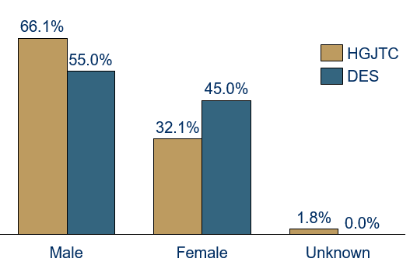

Figure B.1 Comparison of gender breakdown of pre-employment training participants to date and DES participants (using DES national data as at 30 June 2016.

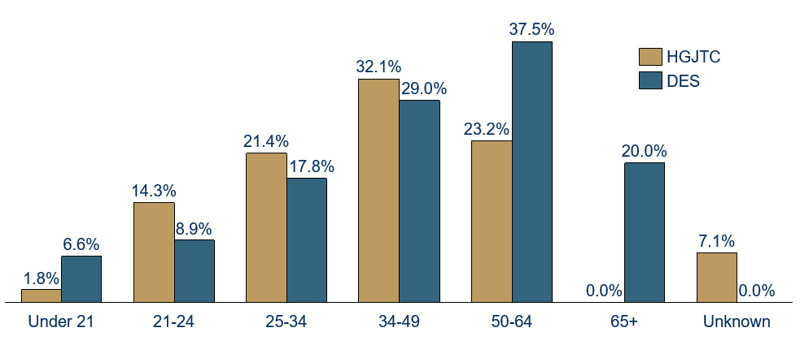

Figure B.2 Comparison of age breakdown of pre-employment training participants to date and DES participants, using DES national data as at 30 June 2016).

Disability type | HGJTC | DES
Physical | 28.6% | 44.3%
Psychiatric | 37.5% | 36.1%
Specific learning/ADD | 3.6% | 3.4%
Intellectual | 5.4% | 4.4%
Neurological | 1.8% | 4.1%
Autism | 14.3% | 3.6%
Hearing | 1.8% | 1.5%
Acquired brain injury | 3.6% | 1.2%
Vision | 1.8% | 1.1%
Speech | 0.0% | 0.2%
Deafblind | 0.0% | 0.1%
Unknown | 1.8% | 0.1%

Table B.2 Comparison of disability type of pre-employment training participants to date, and DES participants (using DES national data as at 30 June 2016).

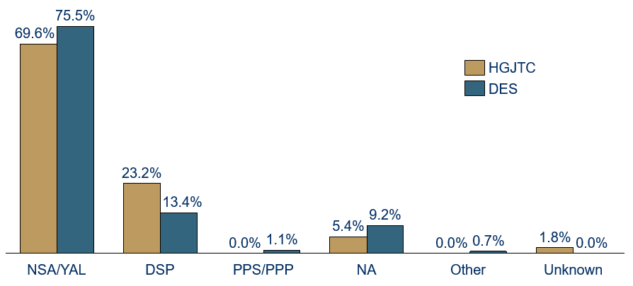
Figure B.3 Comparison of income support payment type of pre-employment training participants to date, and DES participants (using national data as at 30 June 2016).

Note: NSA- Newstart Allowance, YAL – Youth Allowance, DSP – Disability Support Pension, PPP/PPS – Parenting Payment, Non-Allowee – Not receiving income support.

At the commencement of pre-employment training, the Personal Wellbeing Index – Intellectual and Cognitive Disability Version (PWD-ID) was administered to all job seekers. The Index asks survey participants to assess their satisfaction on a 0–10 scale across seven domains — standard of living; health; achieving in life; personal relationships; safety; community connection; and future security. The scores are then converted into a PWI score in a range of 0–100. The normal range for the Index is from 73.9-76.7.

To date, the average score for HGJTC program participants at the pre-employment training was 46.6. The figure below represents the number of participants that fall above, in, and below the normal range.

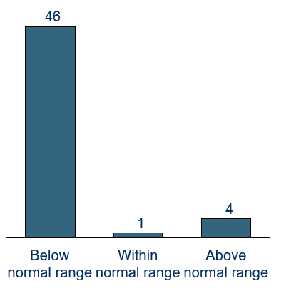

Figure B.4 Baseline Personal Wellbeing Index scores. Note: incomplete surveys were excluded.

The Personal Wellbeing Index will be administered to all participants six months on from the pre-employment training, or at the end of the program (whichever comes first).

ABS 4430.0.10.001 Survey of Disability, Ageing and Carers 2015, first results released 29/4/16.
Barbara Broadway and Duncan McVicar. Reducing the Generosity and Increasing the Conditionality of Disability Benefits: Turning the Supertanker or Squeezing the Balloon? Melbourne Institute Working Paper Series, Working Paper No. 11/15, June 2015 as cited in Australian Government Department of Social Services, New Disability Employment Services 2018 Discussion Paper, 2/11/16.
DEEWR, Employer perspectives on recruiting people with disability and the role of Disability Employment Services, August 2011.
Australian Government Department of Social Services, New Disability Employment Services 2018 Discussion Paper, 2/11/16.
Employment of People with Disability, 29/10/15.DEEWR employer survey cited in Minister Ellis Review of Employment Services Issues Paper, December 2012.DEEWR, Employer perspectives on recruiting people with disability and the role of Disability Employment Services, August 2011.NCVER, What would it take? Employer perspectives on employing people with a disability, Peter Waterhouse, Helen Kimberley, Pam Jonas and John Glover, Group Training Association of Victoria, 2010
NSW Government, Employment Enablement Strategy, http://www.adhc.nsw.gov.au/sp/delivering_disability_services/employment-enablement-strategy, 2016.
AND, Access and Inclusion Index, https://accessandinclusionindex.com.au/, 2016.
DSS, New Disability Employment Services from 2018: Discussion Paper, https://engage.dss.gov.au, 2016.
NDS et al, Economic Benefits of the NDIS in NSW, 2015.
NSW Government, Smart, Skilled and Hired, http://www.industry.nsw.gov.au/live-and-work-in-nsw/working-in-nsw/smart-skilled-and-hired, 2016.
Social Ventures Australia, Growth Industries Analysis, 2015.
Providers have delivered all training using existing DES service fees and at no additional cost to the employer (or in the case of Aspect Employment, using the funds provided by NSW FACS under the Employment Enablement Strategy to assist the HGJTC project to support candidates on the autism spectrum).
www.jobaccess.gov.au
Supported by many previous employer surveys and the findings of the Business Council of Australia survey 2015 Recognising Ability http://www.bca.com.au/publications/workforce-inclusion-of-people-with-disability
http://lmip.gov.au/default.aspx?LMIP/DisabilityEmploymentServicesData/MonthlyData
Australian Centre on Quality of Life, Personal Wellbeing Index, http://www.acqol.com.au/iwbg/wellbeing-index/, 2005.
Australian Unity, What Makes Us Happy – Third Edition, http://www.australianunity.com.au/about-us/~/media/About%20Us/Wellbeing/What%20Makes%20Us%20Happy%202015.ashx, 2015.

